Blue KC 2022 MA Agent Appointment / Onboarding Guide

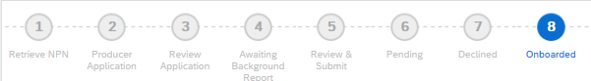
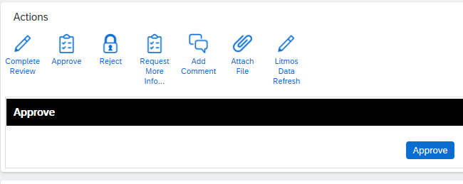
Getting into the 2022 BlueKC Onboarding System:
9. For agents/brokers with KS licenses, select REQUEST APPOINTMENTS, select Health KS license, and SUBMIT
10. Select COMPLETE REVIEW and check each item that was properly reviewed the hit SUBMIT
11. Last, select APPROVE (unless directed to DECLINE) and then Approve again, or if new KS agent REQUEST APPOINTMENT
12. Agent will process and go to ONBOARDED status

Accessing the System:
When onboarding, you will receive an email from Blue KC MA:
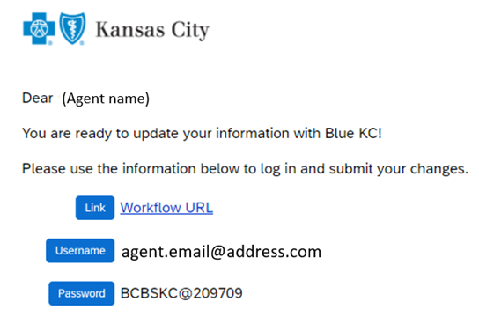
.

Click on the “Workflow URL” in the email above, which will take you to the login screen. Illustration of the login screen is below:
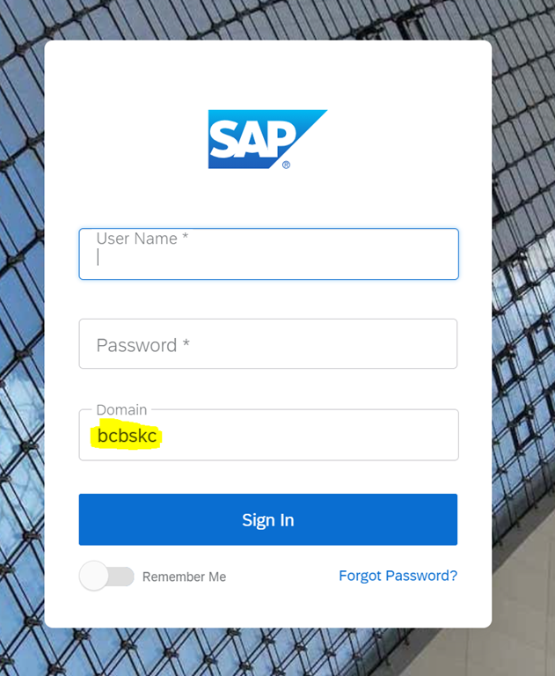

Here you will type in your username & password in the boxes and VERIFY the “Domain” box contains bcbskc

Note:
- DO NOT COPY AND PASTE into these fields. There are security features that prevent that feature from allowing you to login.
- If you have disabled the ability to click on links in your email, you can click the following link or copy and paste the link into your browser:
  - https://social.webcomserver.com/wpm/mt/bcbskc/

Forgotten Password:
If you have forgotten your password, please click the link in the lower right “Forgot Password” (as illustrated in the previous screenshot). This will take you to the following screen:
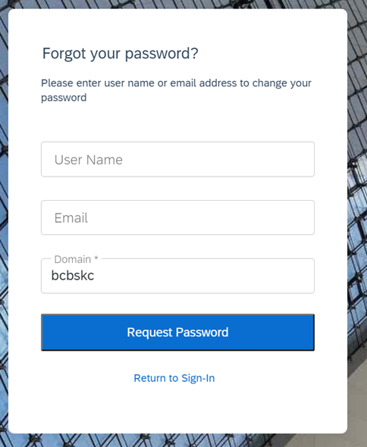

Here you will enter your username (usually your email address) and the email address where you want to receive the reset link. Once you have entered the data, click the blue box: “Request Password” button, causing a password reset email to be sent.

Note:
- Be sure to check your spam or junk folder, email systems often put password reset emails in these folders.

Navigation in the System:
After you have logged in, you will be presented with the “Open cases assigned to me”.
It is possible that you will have more than one case assigned to you; for example, if you are also the principal of an agency and you use the same email for both.

Click on the “Onboarding-OB-xxx”
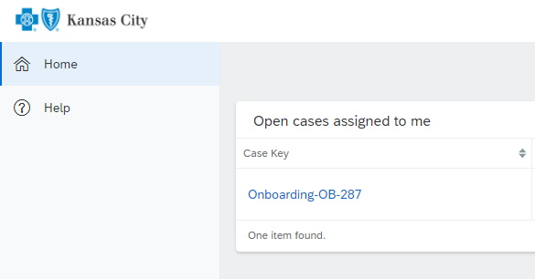

Next you will be taken to a page where you can enter either your Social Security Number or your NPN. Entering either, will perform a NIPR (National Insurance Producer Registry) search of their Producer Database (PDB) to verify that you are a valid producer.
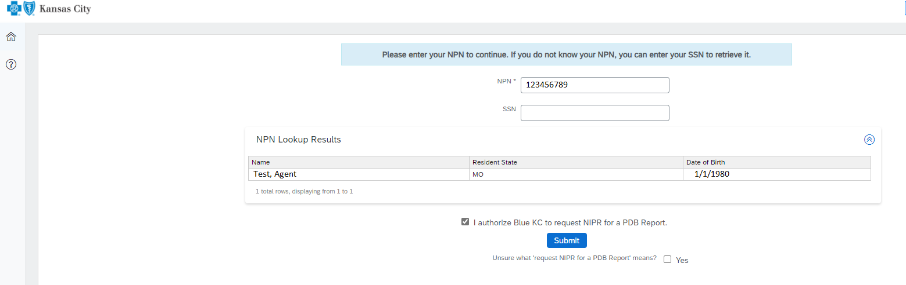
Once your data is entered, click the checkbox authorizing Blue KC to perform a search of the referenced database. When a positive result is obtained click the blue “Submit”.
Note: This is a required step to begin the onboarding process and cannot be bypassed. Blue KC does not manage anything regarding the NIPR databases so you will have to contact NIPR to resolve any perceived discrepancies returned in the report. If you have questions regarding the NIPR PDB Report, click the checkbox next to “Unsure what ‘request NIPR for a PDB Report’ means?”

Congratulations, you can now access the system and can begin onboarding!

Completing the Onboarding:
9. For agents/brokers with KS licenses, select REQUEST APPOINTMENTS, select Health KS license, and SUBMIT
10. Select COMPLETE REVIEW and check each item that was properly reviewed the hit SUBMIT
11. Last, select APPROVE (unless directed to DECLINE) and then Approve again, or if new KS agent REQUEST APPOINTMENT
12. Agent will process and go to ONBOARDED status

The below sections illustrate the various tabs that you must review and update to successfully complete and submit your onboarding application.

Note:
- On any given tab, at the top of your screen there are two buttons:
  - “Save” Button - This allows you to save your work, logoff, and later resume where you left off.
  - “Submit” Button - This fully submits your application to Blue KC. ONLY click this AFTER all tabs are completed.
    - Important Note: Blue KC will NOT receive your onboarding application if the “Submit” button is not hit upon completion

- General Tab
  - Within this tab you will presented with information to input or correct, then click “Next”. Illustration below:
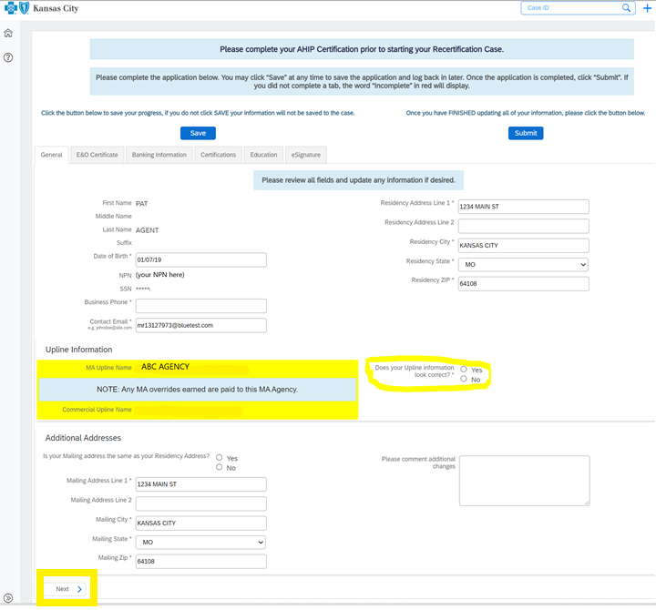
    - Note: If you have an upline then you must input an answer for questions regarding your upline
- Licenses Tab
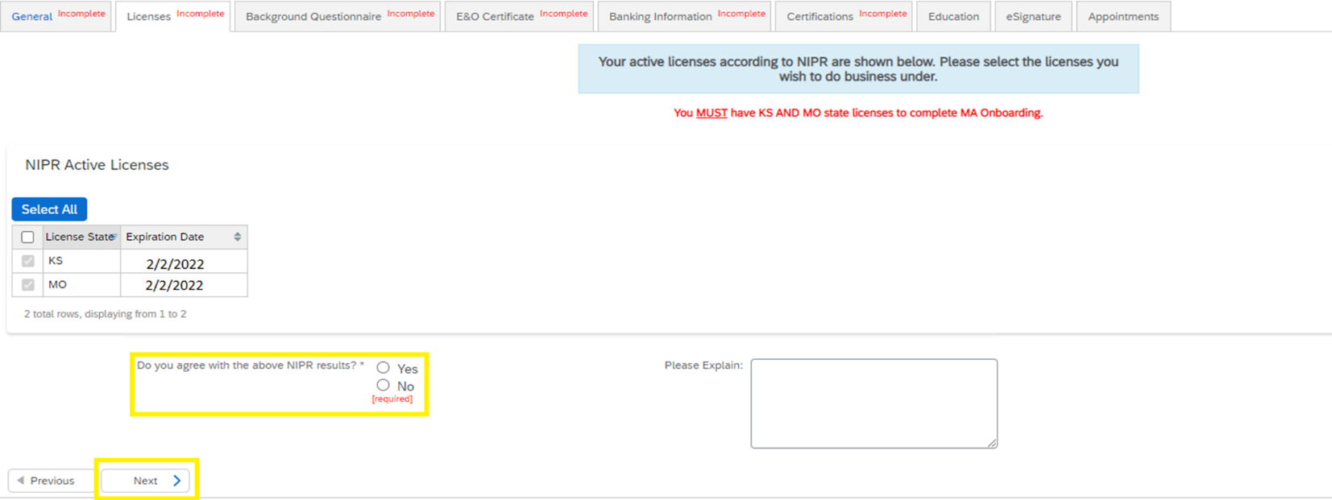
- This tab will be populated with NIPR data, specifically your insurance license(s) from the corresponding state(s). Verify or reject the results (with required explanation) by clicking “Yes” or “No” and then click “Next”. Illustration below:

- Background Questionnaire Tab
- Within this tab, you will answer a few brief background questions. Select “Yes” or “No” for each question and then click “Next”. Illustration below:
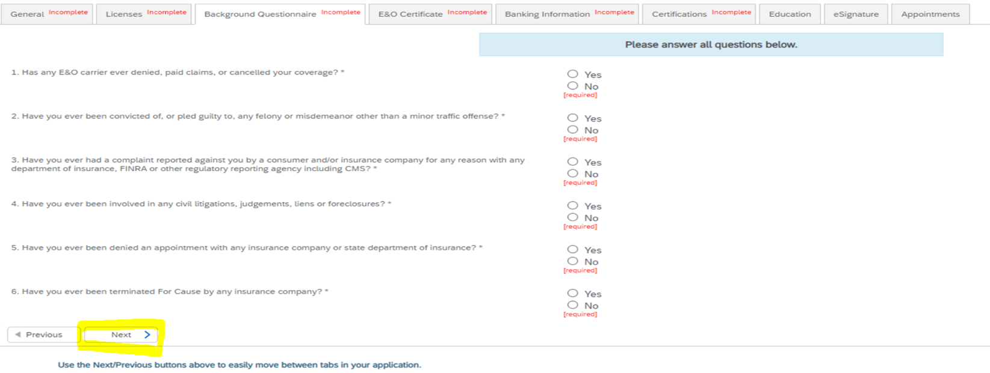

- E&O Tab
- You will completed this tab with your E&O data, review all data, and then click “Next”. Illustration below:
  - If prepopulated from a previous application, you will be asked if you want to change your current E&O data, click “Yes”, and follow the additional steps.
Note: If E&O data is newly or updated then a copy of your E&O (at least the disclosure page) must be uploaded into the system
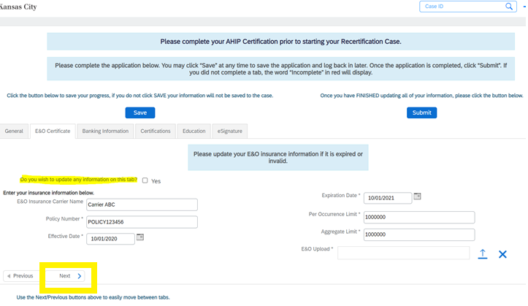
Note: The Per Occurrence Limit and Aggregate Limit both must be at least 1,000,000
To upload a copy of your E&O follow these steps: 1. Click within the blank E&O box 2. Navigate to your wherever you saved your copy of your E&O, 3. Click the Open Icon
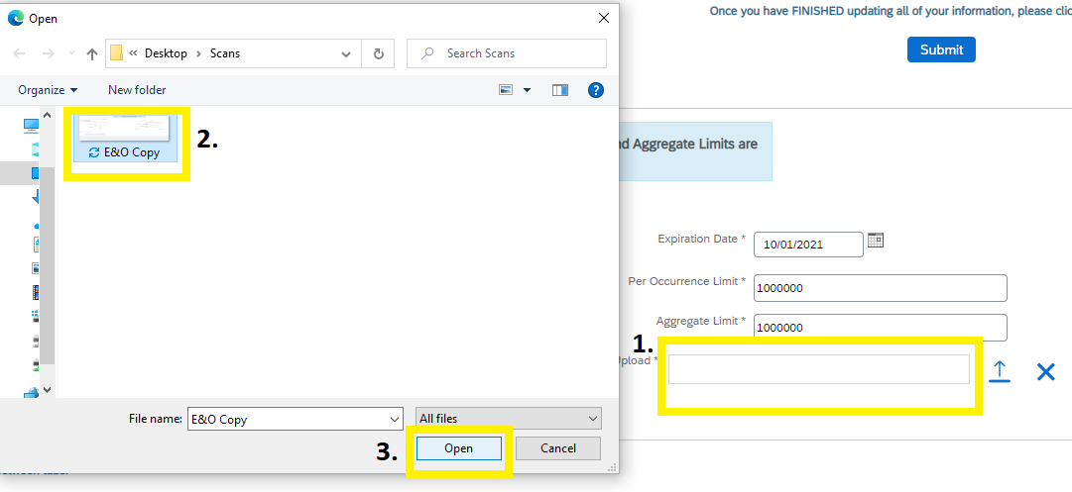

- Banking Tab
- Within this tab banking information is updated. Input, update, and review your banking information for all applicable lines of business a W-9 and then click “Next” when finished. Illustration below:
  - Note: For agents under LOAs, where your Upline Agency determines pay, nothing is needed here so you can just click “Next”.
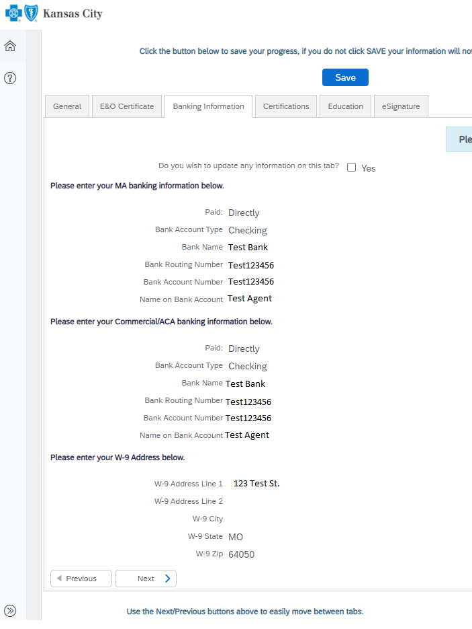

- Certifications Tab
- This tab will need to be populated your AHIP certification data, review and update where needed. Illustrations below:
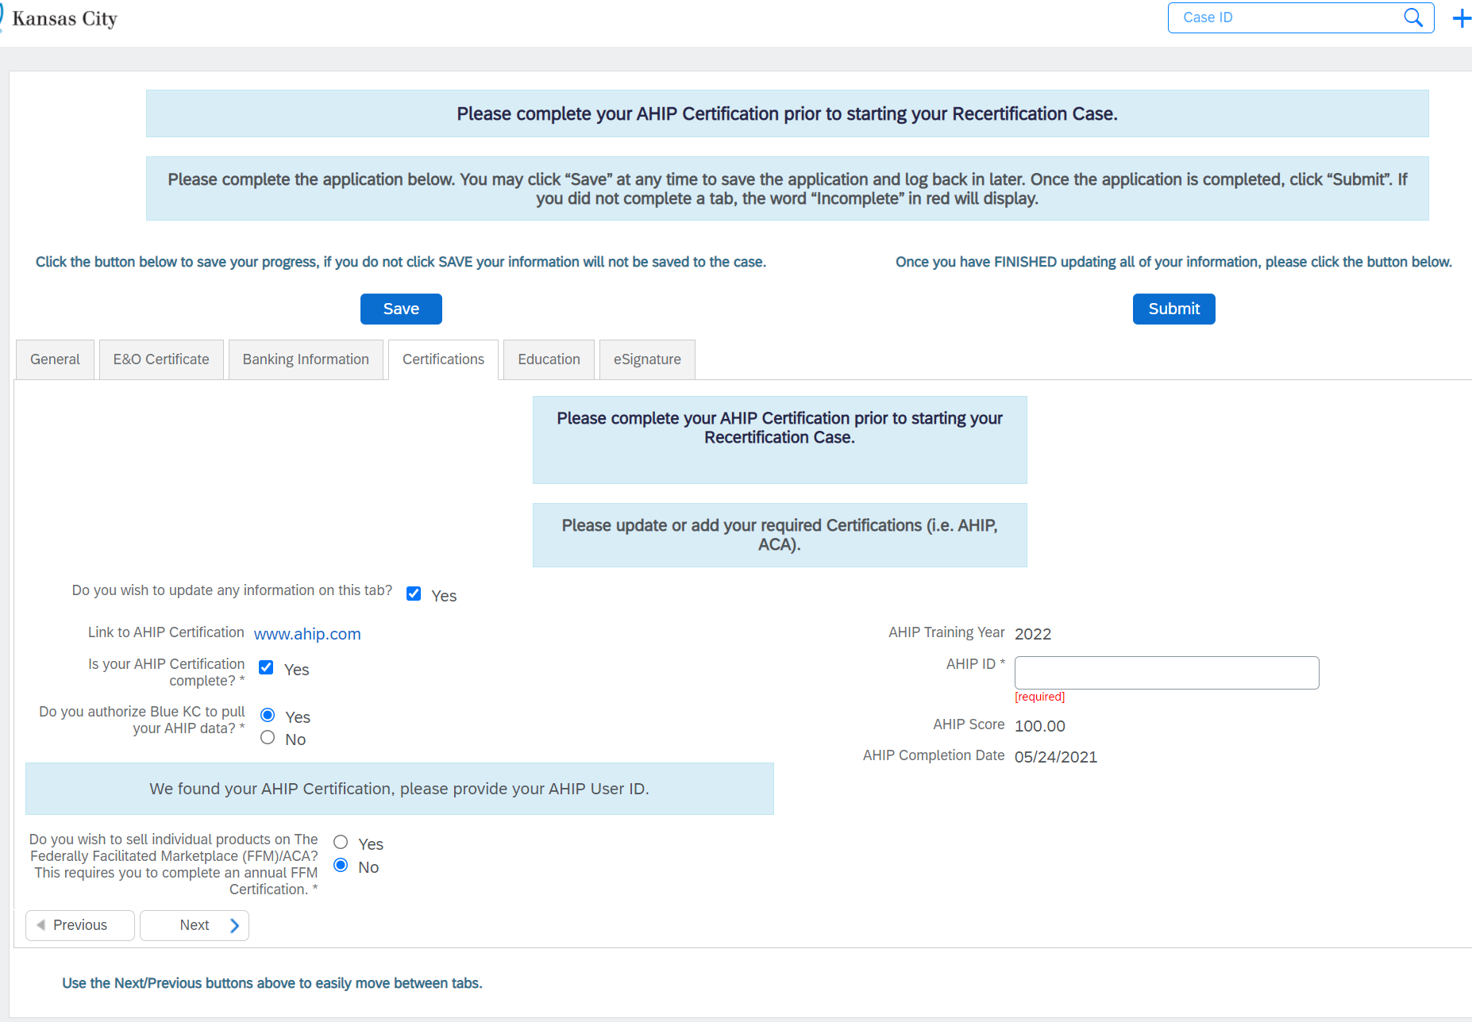

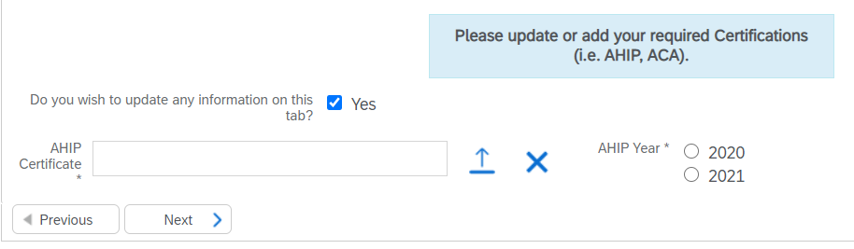

Note: If you have commercial, you can enter your FFM certification OR opt out:

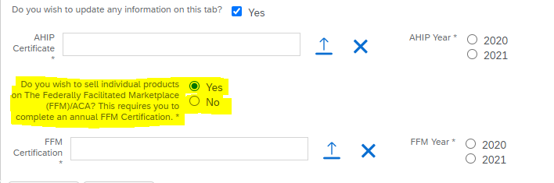

- Education Tab
- This tab will load into another system where you will complete a 10-question exam. Illustration screenshots below:
  - Note: You will get 3 attempts to pass the exam with a score of 85% or higher.

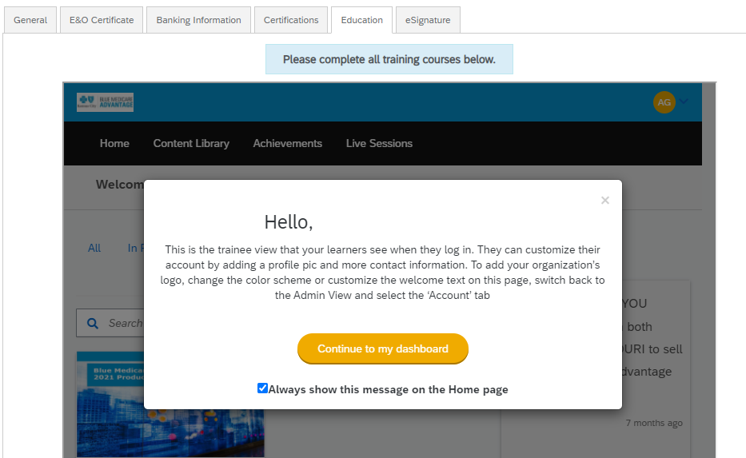
When you first log in a system message will popup; simply click “Continue to my dashboard”

Click the 2022 Blue KC MA Training icon below. After you view the training guide, you will see the Exam!
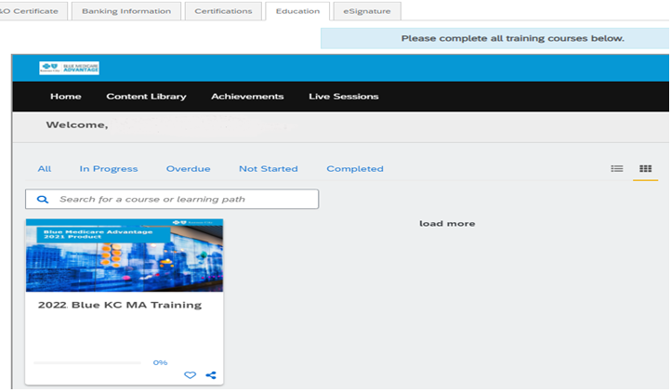
Note: If you are also onboarding for ACA, you will see the ACA Training as well.
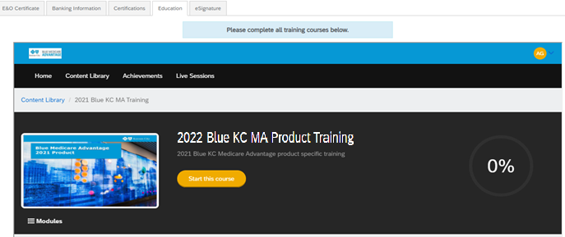
Click “Start this course”

Once inside, click the yellow “NEXT” on the upper right to start your exam.

Go through each question, selecting the bubble next to whichever answer you believe is correct and then clicking “Next Question”
After you answered all the questions, you will be brought to a page where you can review your answers.
- If you would like to change your answer for any given question, click the “Change this answer” under the question
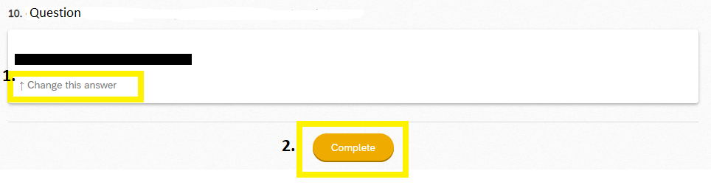
- Scroll to the bottom of the questions/answers list and click on “COMPLETE” to submit your answers for grading.
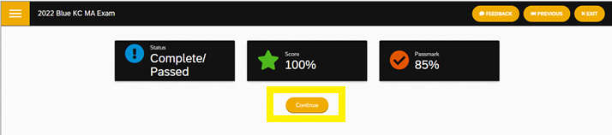
After receiving a passing grade, click “Continue” at the bottom of the page
You will be taken to another page to verify that you have passed the test, from here click “Next” at the bottom of the page
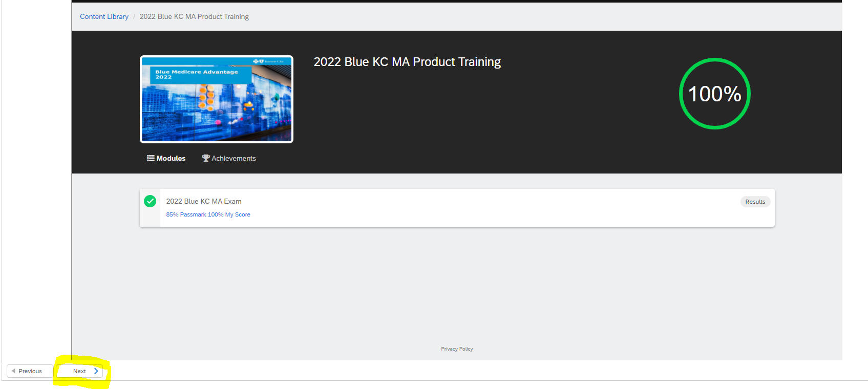

- eSignature Tab
- This tab will allow you to electronically sign certifying that you are who you are, that you have completed the work, etc. You will have to type / sign your name and information multiple times throughout the document before you are finished.
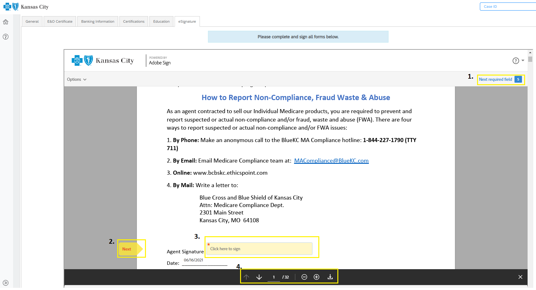
  - Note: This process is done through Adobe Sign, so you might be prompted to update your browser to become compatible with the software. You might have to click the blue button “Load Documents” for them to appear.
    - This tells you how many more signature fields are found within the document.
    - If you click “Next”, then it will take you to the next signature field or required input within the document.
    - By clicking within the signature field, your established signature will be input.
      - The first time you click within the signature field, you will receive a prompt asking you to create a digital signature (for its simplicity we recommend the “Type” option, but feel free to use whatever option you desire).
        - Signature Options:
          - You will have the option of typing it out
          - Drawing it with your mouse
          - Uploading a scanned image of your actual signature
          - Syncing with a mobile device to create a signature)
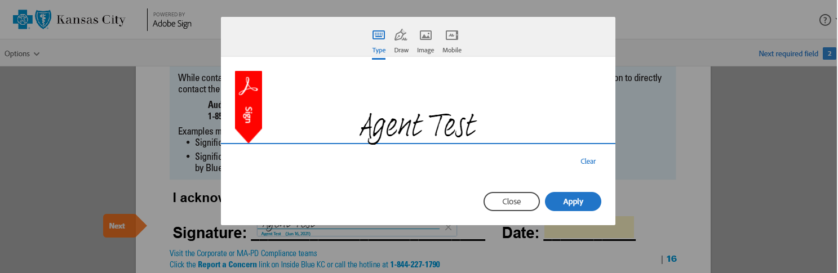
      - Once you are done creating your signature click “Apply”
    - These are Abode shortcut icons to perform various tasks (from left to right: page up, page down, X current page / total pages, zoom in, zoom out, & download)
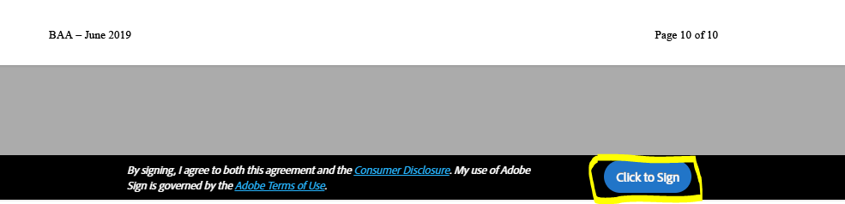
Once you have signed & completed all the required fields you will be able to “Click to Sign”, finalizing that document.
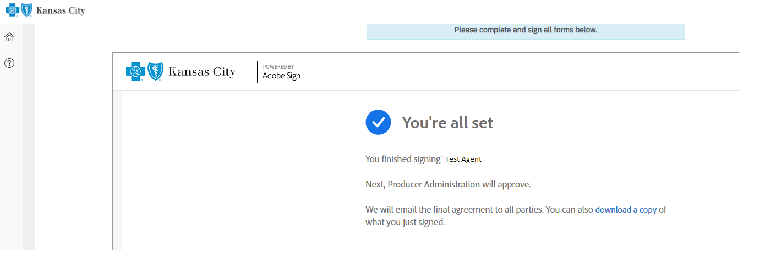
When the document is complete you will receive a confirmation message like the below:

Repeat the previous process if you have any additional document, otherwise return to a previous tab, or proceed to the next step.

- Appointments Tab
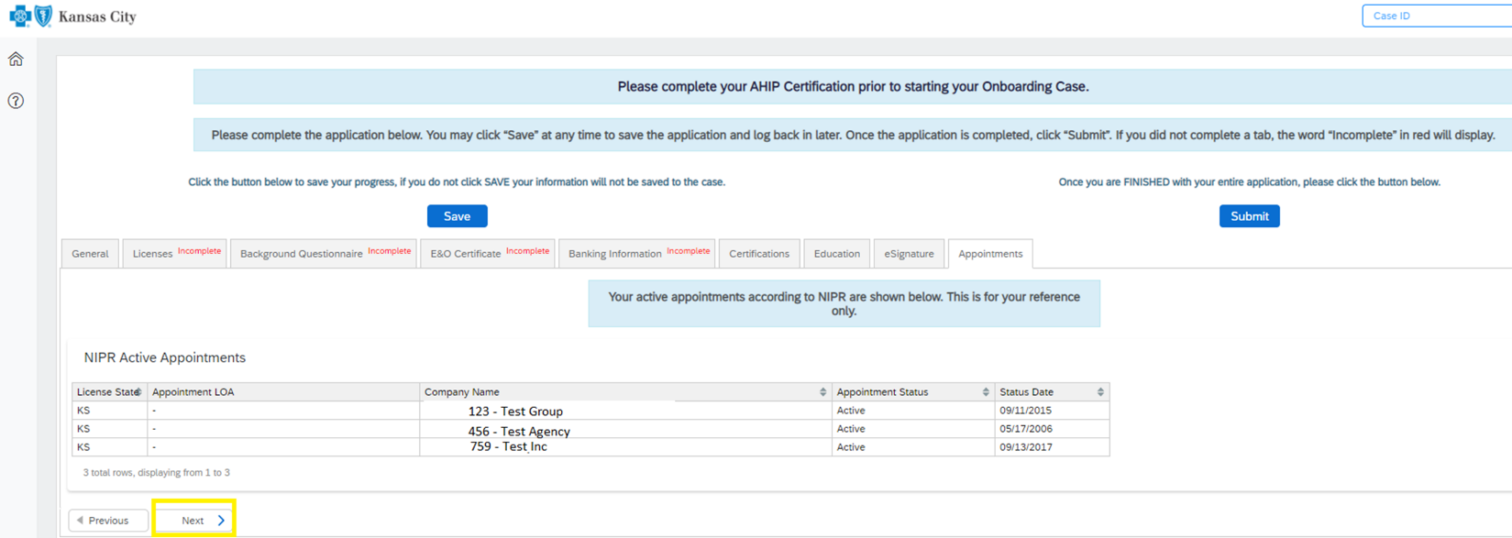
- This tab will be populated with the active appointments / onboardings of yours that NIPR is reflect. This tab is purely for review purposes and the data is owned by NIPR, so once you are done reviewing click “Next”. Illustration below:

- “Submit” Button
- When you have completed all relevant information and no longer see “Incomplete” next to any tab, click the “Submit” button, near the top of the page.
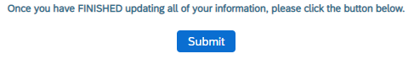

- If everything was performed correctly, you will see the below message:
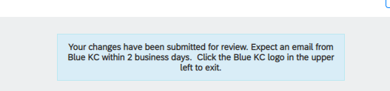

At this point you are free to logout, close your browser, etc.

Thank you!

